Lab 02

Rectification
Name: Syed Sualeh Abbas, Muhammad Haider Zaidi | Student ID: 10303

Objective
To investigate the performance of half-wave and full-wave rectification circuits implemented using diode.
The CLOs, LDLs and PLOs mapped on in this lab are:
CLO | Description | LDL | PLO
CLO 1 | Investigate characteristics of basic electronic devices and their application in development of electronic solutions. | Psy - 3 | PLO-4
CLO 4 | Demonstrate ethical values by complying with instructions and practicing punctuality and integrity | Aff - 3 | PLO-8

Note: 1.All the waveforms must be clearly drawn with proper labelling. 2. You can only use pencil to draw the waveforms, whereas, for the rest of the analysis and readings use pen.

Introduction
Rectifiers are the circuits which convert Alternating Current (AC) to Direct Current (DC). Diode, a unidirectional two-terminal non-linear electronic component, is a fundamental element of rectifiers because of its ability to conduct current in one direction and block in the other direction. Rectifiers can be classified into two classes; half-wave rectifiers and full-wave rectifiers. Full-wave rectifiers are further characterized into two types that are center-tapped rectifier and bridge rectifier. Rectifiers are found in all DC power supplies that operate from an Alternating Current (AC) voltage source.
Performance of a rectifier can be measured using a parameter called ripple factor. The smoother the output waveform, the smaller the ripple factor is. A perfect DC output does not have any ripples or in other words any AC component. Consequently, the RMS component is equal to the DC component which results in 0 ripple factor. Ripple factor can be expressed as:
Where, V_{rms} is the root mean square value of output voltage and V_{dc} is the average or mean value of output voltage which is equal to the DC component.

Half-wave Rectifier
Half-wave rectifier is shown in Figure 2.1. Its working principle is based on the bias condition of diode. Since diode allows current to pass through it only when it is forward biased and behaves as an open-circuit when it is reverse biased, therefore, when AC sinusoidal signal is applied to a load through diode, the current flows through the load only in half cycle of the input sinusoid where the diode is forward biased. Thus, the AC sinusoidal input voltage is converted into pulsating DC through half-wave rectifier.
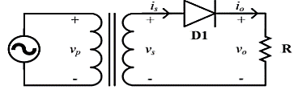
Figure 2.1: Half-wave rectifier circuit

Task 1: To simulate half-wave rectifier circuit using PSpice
Figure 2.1 shown implementation of half-wave rectifier circuit in OrCAD PSpice. Here, an AC voltage source is connected to a step-down transformer (240V/24V). The AC voltage source of 240V with 50 Hz frequency simulates supply from outlet at your home. The amplitude is reduced down using a step-down transformer. Usually, the required output of DC power supply is not as high as 240V therefore, before rectification, the amplitude of AC signal is stepped down.
Figure 2.1: Schematic for simulation of half-wave rectifier circuit
- Implement the circuit using OrCAD Capture. PSpice model name of the AC voltage source is VSIN. To add a transformer, go to Place> PSpice Component > Modelling Application > System Modules > Transformer. Make sure Two Winding is selected. In listed properties, change turns ration to 0.1 i.e., the secondary voltage is 10 times lesser than the primary voltage. At the output terminals, connect a load resistor of 1kΩ through a half-wave rectifier (diode model 1N4007).
- Run Transient Analysis and set run time to 0.2sec to at least view 10 cycles of AC supply. Set the value of maximum step size to 0.001sec, in order to get a smoother waveform.
- Obtain waveforms of voltage across load, voltage across diode (using differential voltage markers) and secondary voltage of transformer. Obtain current waveform in a separate window. Add captures of the obtained plots.

- In which half cycle of the supply, the diode conducts? Explain how you can identify the conduction of diode from the obtained waveforms.

- Can we say that the circuit works as a rectifier? Justify your answer. Why this rectifier is called half-wave rectifier?

- For the obtained output voltage, measure the parameters listed in Table 2.1.
PSpice Measurement Help:
- To add plots for RMS (Root Mean Square) and average values of the output voltage, go to Trace > Add Trace. In Add Traces Window, you will see Functions listed at right hand side. Select RMS ( ). In parenthesis, write the expression of output voltage V (R1:2 - R1:1) where, terminal 2 of R is connected to ground. Discard starting few cycles, consider the waveform when voltage becomes stable.
- Similarly, add trace for average value by selecting AVG ( ) from functions. In parenthesis, write the expression of output voltage V (R1:2 - R1:1) where, terminal 1 of R is connected to ground.
- Exact value can be read using cursors for the added traces. When measuring the values, ignore the first few cycles.
- Frequency can be calculated by measuring the time period of waveforms.
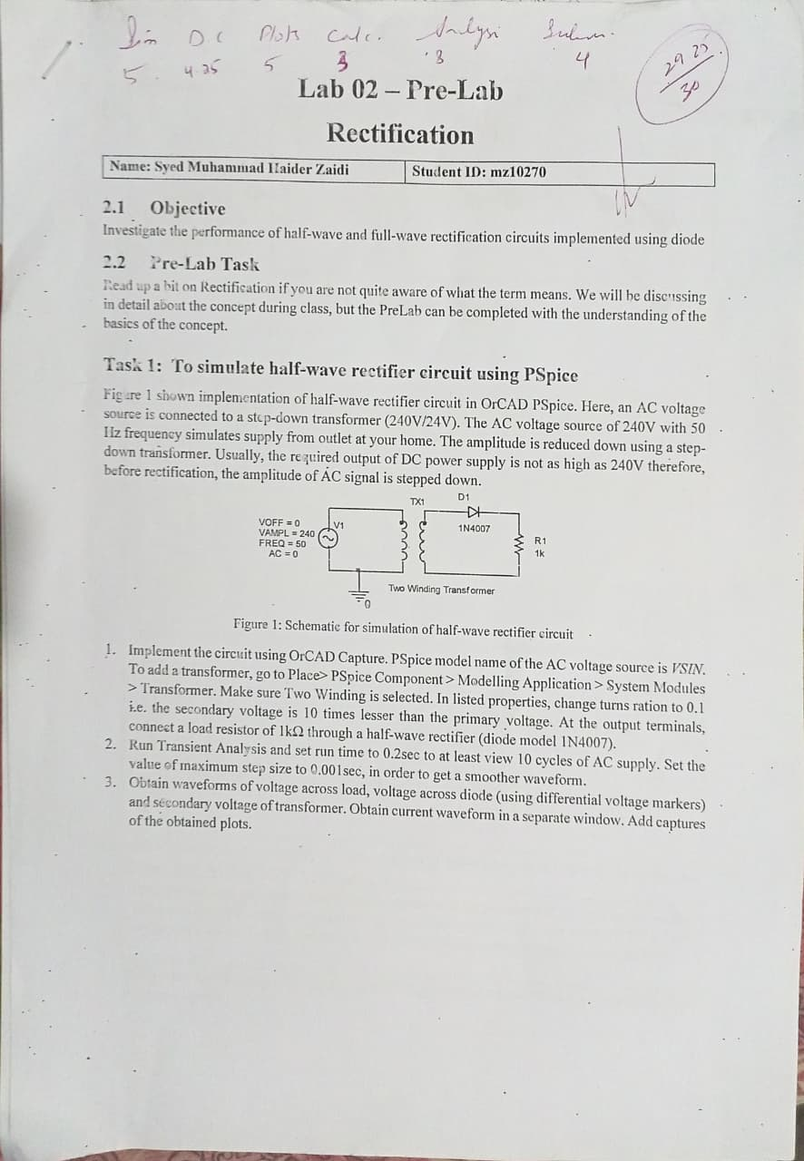

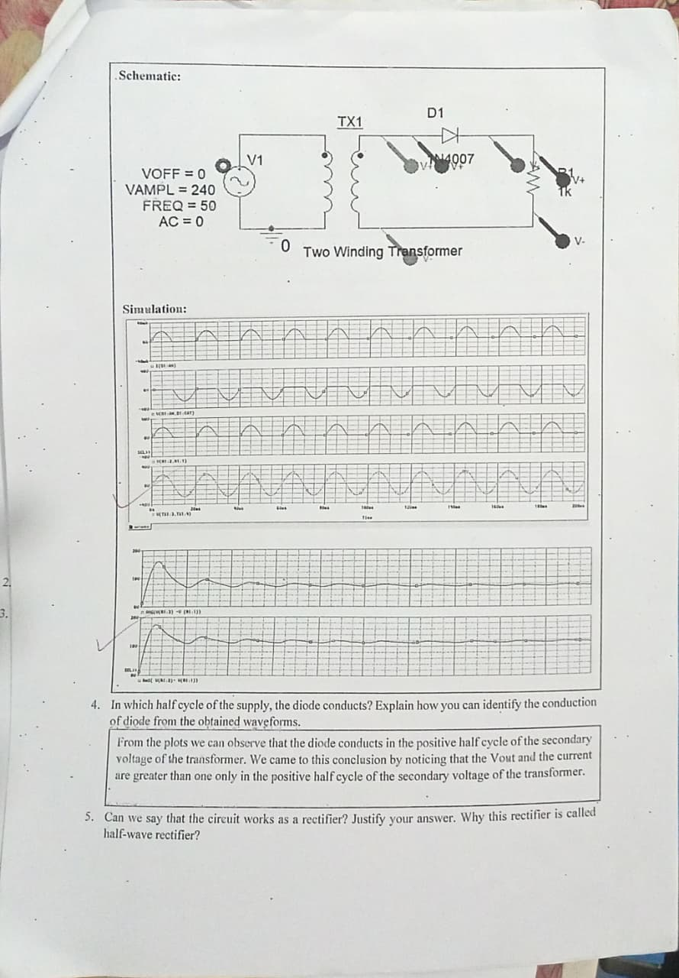

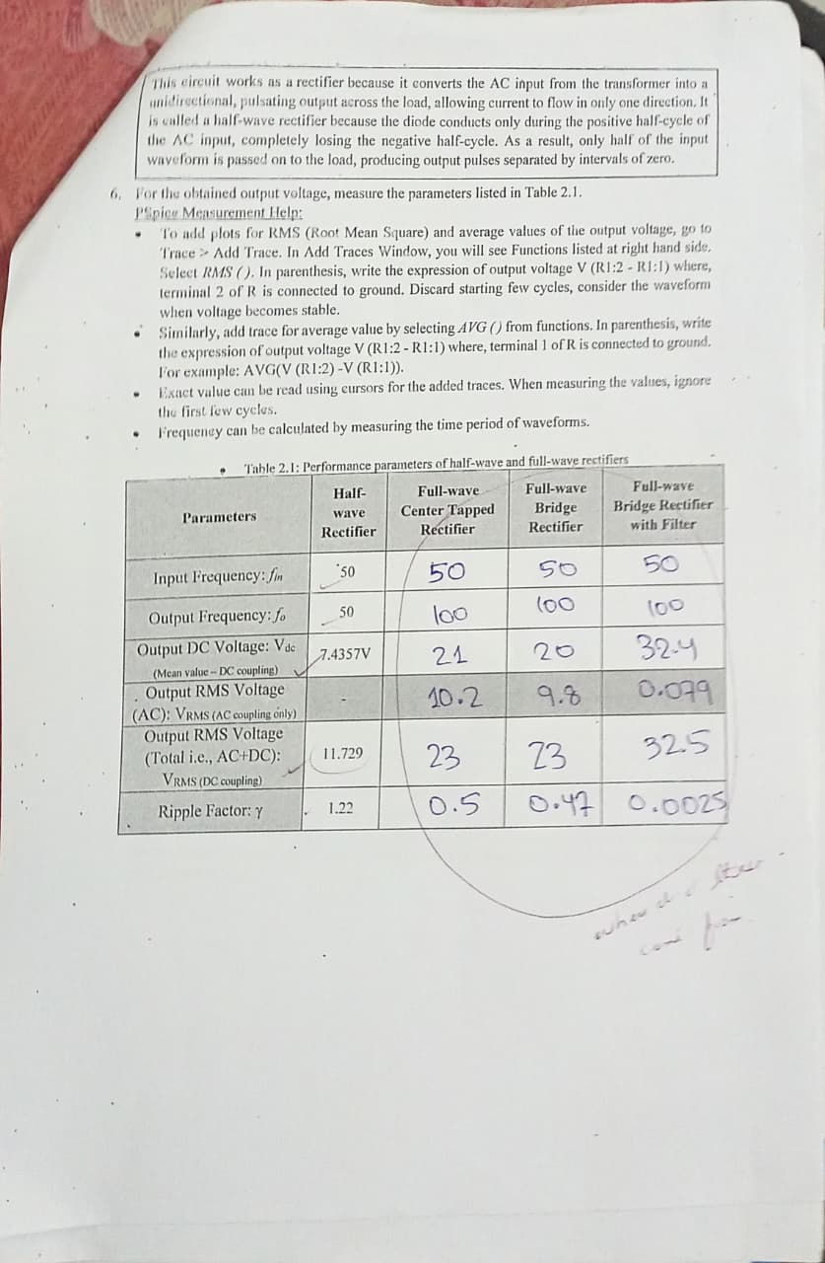

Full-wave Center-Tapped Rectifier
A full-wave center-tapped rectifier uses two diodes as shown in Figure 2.2 to allow both; the negative and the positive, half cycles of the input AC voltage to appear across the load such that the current through the load does not change its direction. Thus, full-wave of the applied AC input is rectified. The two diodes are connected to the opposite ends of a center-tapped transformer where the center-tap is usually considered as the reference ground. The voltage that appears at the 2 secondary terminals of transformer with respect to center tap is always equal in magnitude but opposite in polarity.
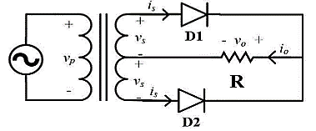
Figure 2.2: Full-wave center-tapped rectifier circuit

Task 2: To implement full-wave center tapped rectifier circuit on hardware
- Figure 2.3 shows the circuit implementation of a full-wave center tapped rectifier circuit. Construct this circuit and use RL=1K ohm of 0.5W rating.
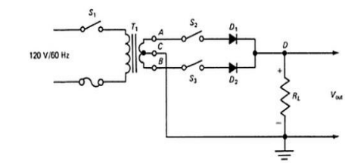
Figure 2.3: Schematic of full-wave center tapped rectifier
- To understand the secondary voltages of center, tap transformer, obtain waveforms of voltage across the 2 secondary terminals with respect to the center tap using the digital Oscilloscope. Make sure your oscilloscope probe is set to 1x. Sketch and label the waveforms. Mention pk-pk voltages, frequencies and also make sure the references of both the waveforms are aligned.

- Observe the waveforms of voltages, first open circuit the Diode 2 using switch and measure voltage across Diode 1, then open circuit Diode 1 and close circuit Diode 2 to measure the voltage across diode 2. Sketch and label both the waveforms in graph 1.

For diode one:
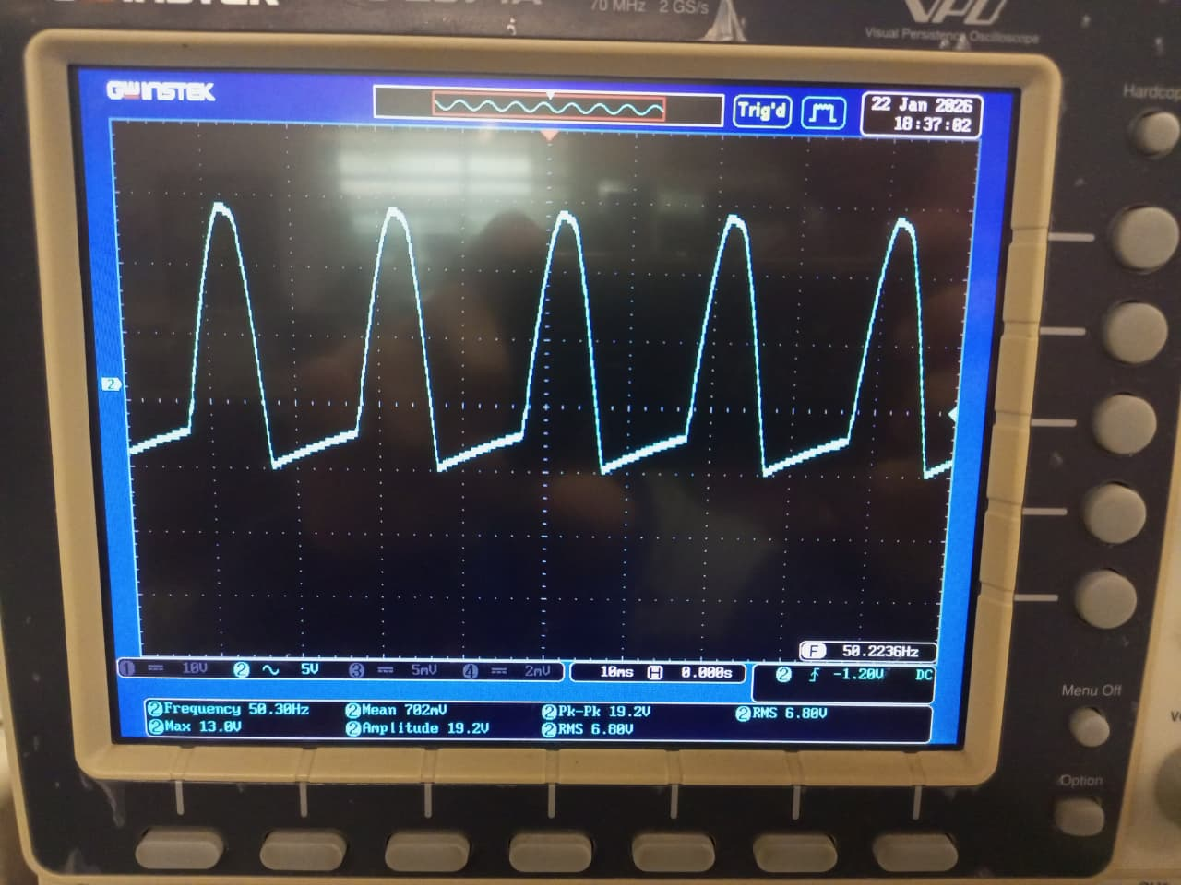

For diode two
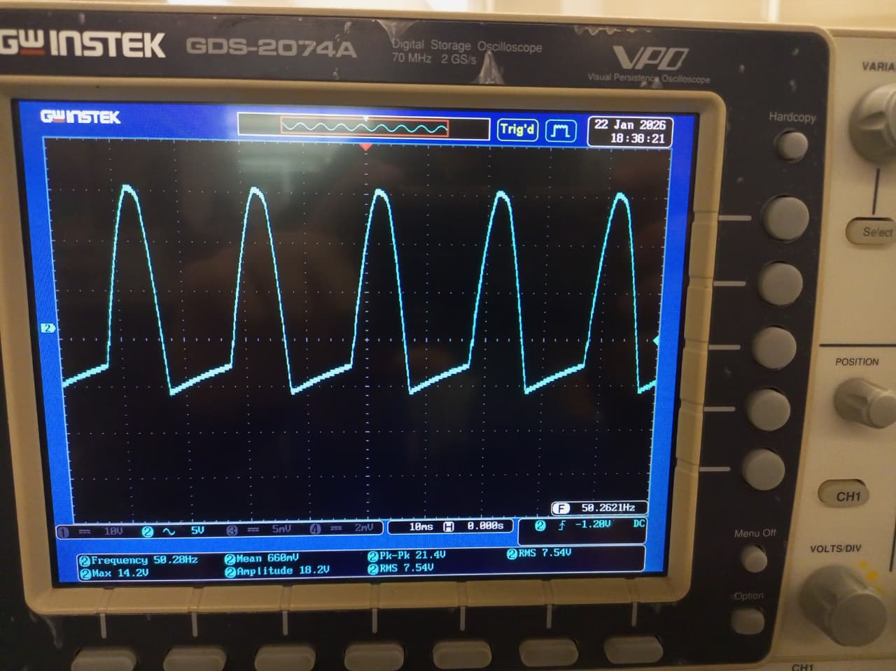
- Now, close both the switches and measure voltage across the Load resistor. Sketch and label the waveform in graph 2.
Both switches closed:
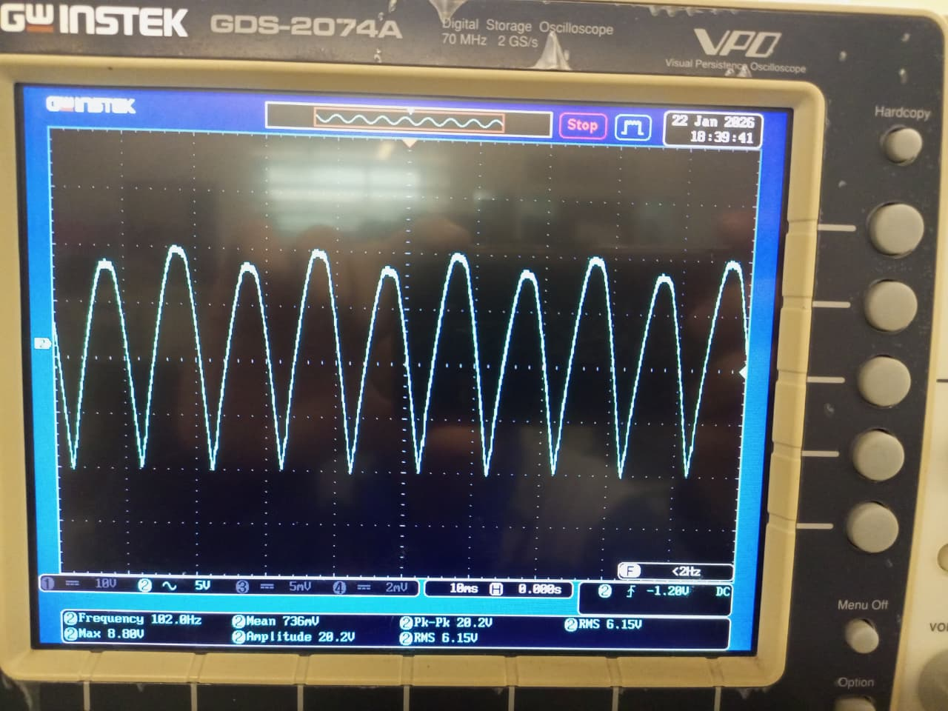

- Take measurements for the parameters listed in Table 2.1 and fill in the column for center-tap rectifier.

How to set AC or DC coupling in Oscilloscope?
If the probe is connected to Channel 1 of the scope, then, in order to set coupling, press the CH1 button and you will see that it lights up just like Figure below and on the bottom of the screen 3 options under coupling will appear DC AC GND.

- DC- represents the scope will show both AC and DC components of the waveform/signal.
- AC-represents the scope will show only the AC component of the waveform/signal.
- GND- suppresses both the AC and DC components of the waveform/signal, it is generally used to set the wave/signal to a specific reference position on the screen.
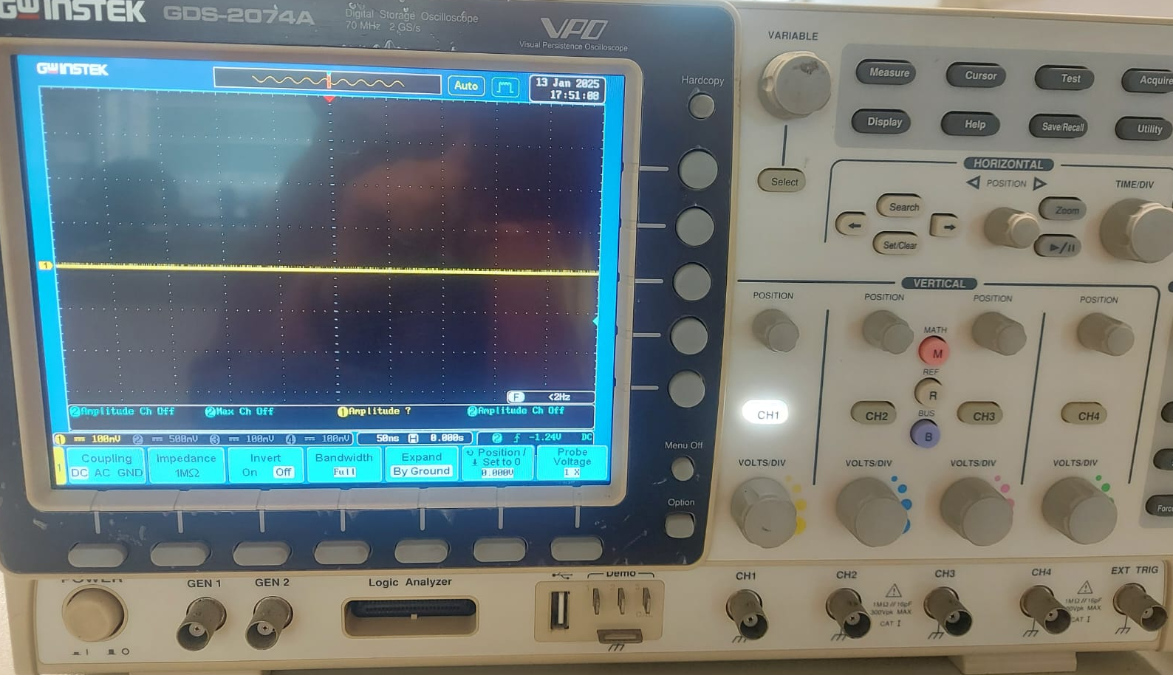

In order to select any of the above stated options press the button highlighted in the Figure below:

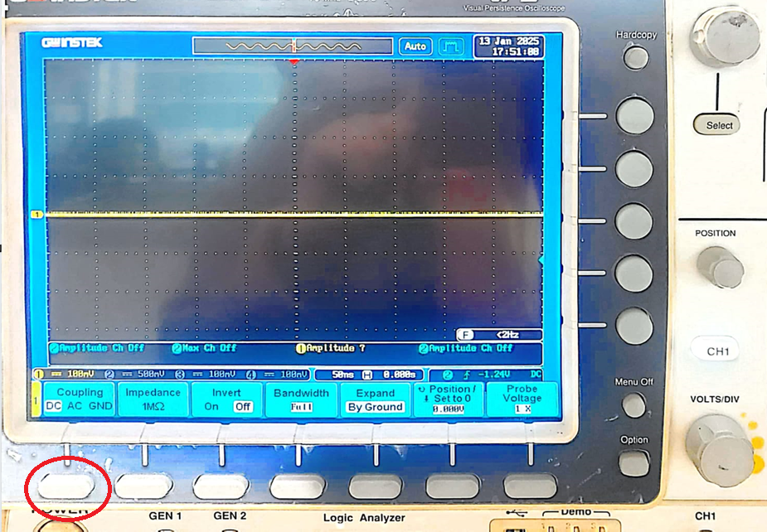

- Using the output waveform obtained in this experiment, compare it with the half-wave rectifier output studied earlier. Identify at least three differences based on waveform shape, ripple content, and average output voltage. Support your answer using your observed waveforms?

1. Waveform Shape:
- Half-wave: Shows triangular/sawtooth pulses with long gaps between pulses where voltage drops to zero. Only positive half-cycles are present.
- Full-wave: Displays continuous alternating triangular pulses with no zero-voltage gaps. Both half-cycles are rectified and appear as consecutive positive pulses.
2. Ripple Content:
- Half-wave: Higher ripple content with significant voltage variation and longer discharge periods between pulses, resulting in poor DC quality.
- Full-wave: Lower ripple content with more frequent charging cycles (double the frequency), producing smoother DC output with smaller voltage fluctuations.
3. Output Frequency:
- Half-wave: Output frequency (~50Hz) equals input AC frequency, providing one pulse per input cycle.
- Full-wave: Output frequency (~183Hz, approximately 100Hz expected) is double the input frequency, providing two pulses per input cycle, which significantly improves ripple performance.

- Explain why only one diode conducts at a time.
During the positive half-cycle of the input AC:
  - Terminal A becomes positive with respect to center-tap C
  - Terminal B becomes negative with respect to center-tap C
  - Diode D₁ is forward-biased and conducts
  - Diode D₂ is reverse-biased and blocks
During the negative half-cycle of the input AC:
  - Terminal A becomes negative with respect to center-tap C
  - Terminal B becomes positive with respect to center-tap C
  - Diode D₂ is forward-biased and conducts
  - Diode D₁ is reverse-biased and blocks
Reverse Bias Prevention: Since the voltages at terminals A and B are always opposite in polarity relative to the center tap, when one diode experiences forward bias, the other automatically experiences reverse bias. This ensures that only one conduction path exists at any given instant.

Full-wave Bridge Rectifier
A full-wave bridge rectifier is shown in Figure 2.4. There are four diodes connected in a configuration like that of a Wheatstone bridge. In positive half- cycle, the diodes D1 and D4 will conduct and in negative half-cycle the diodes D2 and D3 will conduct. Thus, the current through the load flows in one direction and full-wave of the input is rectified. This configuration of full-wave rectifier doesn’t require center-tap of transformer.
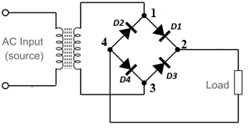
Figure 2.4: Full-wave bridge rectifier circuit

Task 3: To implement full-wave bridge-rectifier circuit on hardware
- Implement the circuit shown in Figure 2.5.
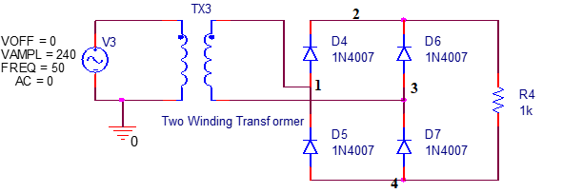
Figure 2.5: Schematic for simulation of full-wave bridge rectifier
- Obtain waveforms of voltage at Nodes 1 and 3 with reference to Node 4 and the output voltage which is at point 2 in with reference to Node 4 in Figure 2.5. Note that, Node 4 is the Reference Node.
- Sketch and label the waveforms in the box below.

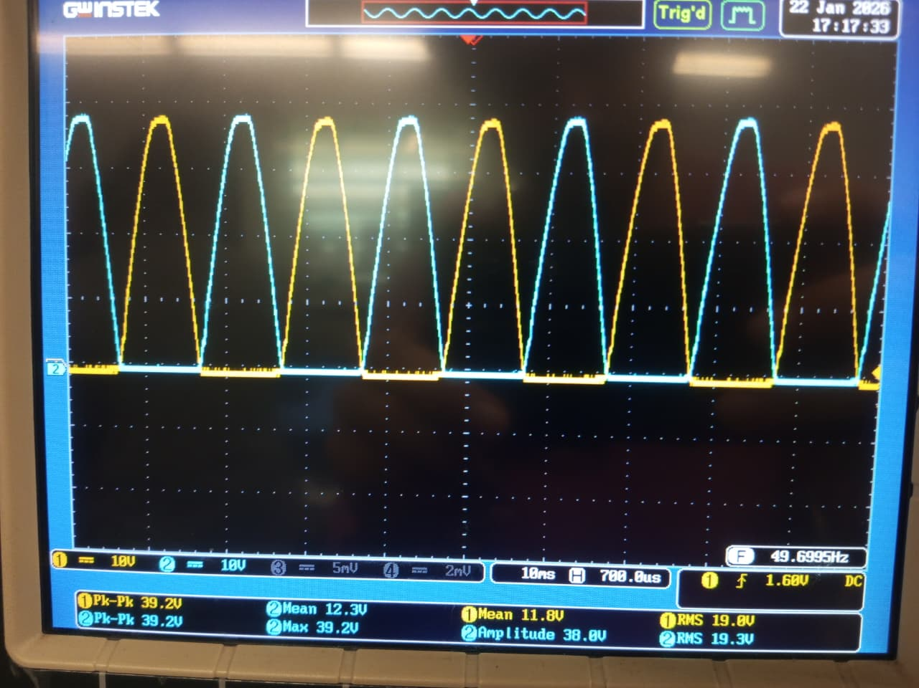
- Identify the diodes that conduct in positive half-cycle of the supply waveform and the diodes that conduct in negative half. Explain why only 2 diodes conduct at a time.
The transformer gives two signals with 180 degree phase shift, as the positive cycle reaches the first two diodes they conduct current, then as this cycle changes to negative, they start blocking the signal, at the same time, the other to diodes which were getting the same signal with 180 degree phase shift, will now conduct the current as the signal for them Is now in its positive half. So we get this ripple affect as shown in the picture above.
- Take measurements for the parameters listed in Table 2.1 and fill in column for bridge rectifier.
- Based on the circuit connections used in this experiment, explain how the bridge rectifier differs from the center-tap rectifier in terms of transformer requirement, number of diodes, and conduction path during each half cycle. Support your answer using the circuit diagram?
Note: You may attach a hand written response and make sure the picture attached is of scanned document and not a raw image.
Center-Tap Rectifier: Requires a center-tapped transformer. secondary winding has three terminals: two ends and one center tap, center tap is connected to ground or reference point. Only one half of the secondary winding is used during each half cycle. It uses 2 diodes; where each diode conducts in the alternating half cycles.
Path:
Positive half cycle: One half of the transformer secondary is positive. One diode conduct, supplying current to the load.
Negative half cycle: The other half of the secondary becomes positive. The other diode conducts.
Current always flows through the load in the same direction. Only one diode drop occurs in the conduction path.

Bridge Rectifier: Requires a normal two-terminal transformer secondary. No center tap is needed. The secondary winding is utilized during both half cycles. bridge rectifier has a simpler transformer requirement compared to the center-tap rectifier. It uses 4 diodes; where two diodes conduct in each half cycle.
Positive half cycle: One diagonal pair of diodes conducts (e.g., D1 and D3). Current flows through the load in one direction.

Negative half cycle: The opposite diagonal pair of diodes conducts (e.g., D2 and D4). Load current direction remains the same. Two diode drops are present in each conduction path.
Table 2.1: Performance parameters of half-wave and full-wave rectifiers
Parameters | Half-wave Rectifier | Full-wave Center Tapped Rectifier | Full-wave Bridge Rectifier | Full-wave Bridge Rectifier with Filter
Input Frequency: f_{in} | 50 | 50 | 50 | 50
Output Frequency: f_{o} | 49.50 | 102 | 100 | 100
Output DC Voltage: V_{dc}  (Mean value in DC coupling mode) | 7.5V | 736m | 26.8 | 31.1
Output RMS Voltage (AC): V_{RMS (AC coupling only)} | - | 6.15 | 11.9 | 5.71
Output RMS Voltage (Total i.e., AC+DC): V_{RMS (DC coupling)} | 11.52 | 6.193 | 29.32 | 31.619
Ripple Factor: γ | 1.29 | 8.35 | 0.4437 | 0.18345

Task 4: Effect of Filters to Reduce Ripples
The instantaneous output voltage of full-wave rectifiers still has ripples as represented through plots and ripple factor. Note that the added Traces for average and RMS values (straight lines) do not represent the instantaneous voltage. These measurements are just a number to measure the average and RMS values of instantaneous voltage that appears across the load.
Filter circuits are used to smoothen the output. Passive filters are made of inductors and capacitors in series or parallel combinations. In this lab, the effect of shunt capacitor-based filter will be investigated. Since a capacitor is open to DC and offers low impedance path to AC current, putting a capacitor across the output will make the DC component to pass through the load resulting in small ripple voltage. The working of the capacitor can be understood in the following manner. When the rectifier output voltage increases, the capacitor charges to the peak voltage V_{m}. After the positive peak the rectifier output voltage tries to fall. As the source voltage decreases below V_{m}, the capacitor will try to send the current back to diode making it reverse biased. Thus, the diode disconnects the source from the load and hence the capacitor will discharge through the load until the source voltage becomes more than the capacitor voltage. The extent to which the capacitor voltage drops depends on the capacitance and the amount of current drawn by the load; these two factors effectively form the RC time constant for voltage decay. A proper combination of large capacitance and small load resistance can give out a steady output.

Task 4: To add filter for reduction in ripple component of rectifier output
- Implement the following circuit change the supply magnitude to 24V. Connect a capacitor in parallel to the load as shown in Figure 2.6.
Figure 2.6: Schematic of bridge rectifier with filter capacitor in parallel
- Obtain waveform of instantaneous voltage across load with and without capacitor. Sketch the waveforms in the graph below.
With capacitor:
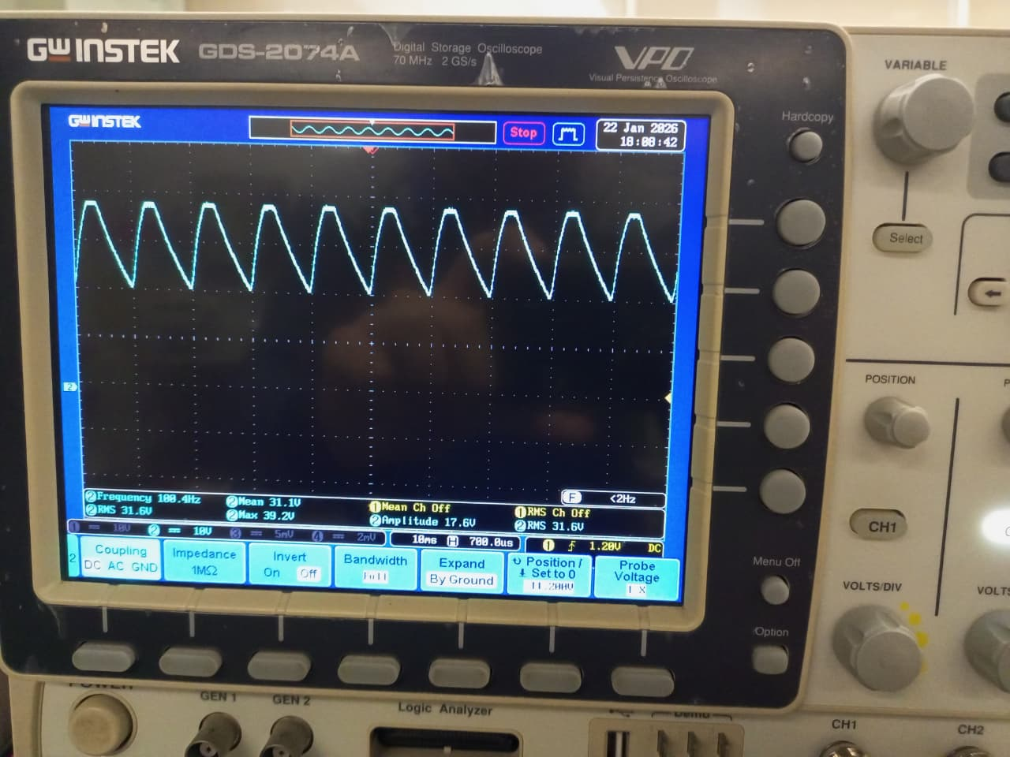

Without capacitor:
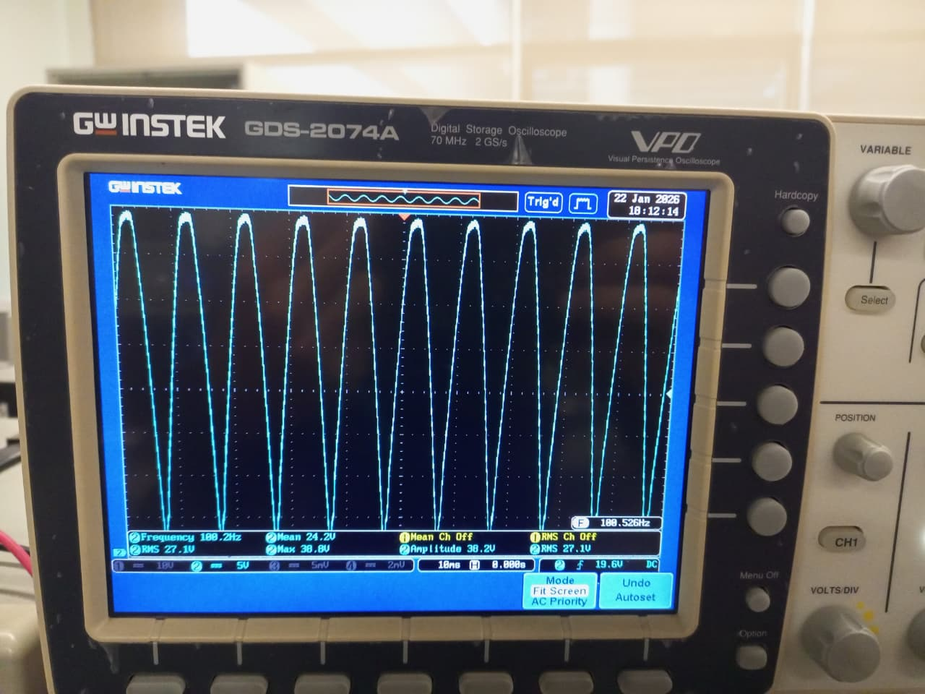

- How is it different from the output voltage without filter? Is there any effect of increasing or decreasing capacitance?

Without Filter (No Capacitor) Output is pulsating DC. Voltage falls to zero between peaks. Large ripple voltage is present. DC (mean) value is low. Output waveform follows the rectified sine wave.
With Capacitor Filter Capacitor charges to the peak value of the rectified voltage. Between peaks, the capacitor discharges slowly through the load. Output voltage remains almost constant. Ripple voltage is reduced significantly
Increasing Capacitance: Capacitor discharges more slowly. Ripple voltage decreases. Output DC voltage moves closer to peak voltage. Smoother output waveform.
- Take measurements and fill in the last column of Table 2.1.

Post Lab

Task 5: To compare the performance of rectifiers
- Compare the performance of half-wave, full-wave center tap and bridge rectifier with and without filter in terms of the listed parameters one by one using the data collected in Table 2.1.
1. Input Frequency: All rectifiers operate at 50 Hz.
2. Output Frequency:
- Half-wave: 49.50 Hz (single pulse per cycle)
- Full-wave rectifiers: ~100 Hz (double pulses per cycle)
3. Output DC Voltage:
- Bridge with filter: 31.1V (highest)
- Bridge without filter: 26.8V
- Half-wave: 7.5V
- Center-tapped: 736mV (anomalous)
4. Output RMS Voltage (AC only):
- Bridge without filter: 11.9V (highest AC ripple)
- Center-tapped: 6.15V
- Bridge with filter: 5.71V (lowest ripple)
5. Total RMS Voltage (AC+DC):
- Bridge with filter: 31.619V (highest)
- Bridge without filter: 29.32V
- Half-wave: 11.52V
- Center-tapped: 6.193V
6. Ripple Factor (γ):
- Bridge with filter: 0.18345 (best - lowest ripple)
- Bridge without filter: 0.4437
- Half-wave: 1.29
- Center-tapped: 8.35
- Given that the rectifier output varies between 12 V and 16 V, design a circuit that maintains the output at 10 V. Draw the schematic and calculate the required component values. Explain how your design responds to input voltage variations.

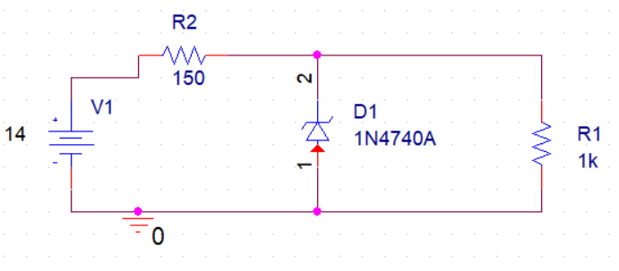
A Zener diode voltage regulator is used to maintain a constant 10 V output when the input varies between 12 V and 16 V. A 10 V Zener diode (1N4740A) is connected in reverse bias across the load to clamp the output voltage. When the input voltage increases, the excess current flows through the Zener diode, keeping the output constant. When the input voltage decreases, the Zener current reduces, but the output remains regulated as long as the Zener diode continues to conduct.
The series resistor R₂ is selected to limit current and ensure the Zener remains in regulation.
With a 1 kΩ load, the load current is:
$$I_{L}=\frac{10}{1000}=10\text{ mA}$$
Assuming a minimum Zener current of 5 mA for proper regulation, the total current is 15 mA.
Using the minimum input voltage (12 V):
$$R_{2}=\frac{12-10}{0.015}≈133 Ω$$
A standard value of 150 Ω is chosen. This keeps the Zener current within safe limits even at 16 V input.

Assessment Rubric
Lab 02
Rectification
Name: | Student ID:

Points Distribution

Task No. | LR2  Simulation  5 | LR 4  Data Collection  20 | LR5  Plots  20 | LR 6  Calculation  12 | LR 10  Analysis  35
Task 1 | /5 | /5 | /5 | /3 | /8
Task 2 | - | /5 | /5 | /3 | /5
Task 3 | - | /5 | /5 | /3 | /5
Task 4 | - | /5 | /5 | /3 | /5
Task 5 | - | - | - | - | /12
Total | /5 | /20 | /20 | /12 | /35
CLO Mapped | CLO 1 | CLO 1 | CLO 1 | CLO 1 | CLO 1

Affective Domain Rubric |  | Points | CLO Mapped
AR 3 | Pre-Lab Submission | /4 | CLO 4
AR 4 | Report Submission | /4 | CLO 4

CLO – (LDL) | Total Points | Points Obtained
CLO1 – (Psy-3) | 92
CLO4 – (Aff-3) | 8
Total | 100

For description of different levels of the mapped rubrics, please refer the provided Lab Evaluation Assessment Rubrics and Affective Domain Assessment Rubrics.

Mean Value can be selected by adding measurements using Measure button in Oscilloscope.

